**Victoria Trans Info**

# Introduction

Alexa skill “Victoria trans info” provides various information about routes, stops, departures and nearby stops for Public Transport Victoria (PTV) (<https://www.ptv.vic.gov.au/>) , Australia. Main objective of the skill is to get latest and up to date information using public API provided by the PTV for the developers. All the information is taken is using the API and it is used for developing the Alexa skill and not to be used for commercial purpose.

# Data Structure

Data structure used by PTV in the api is as following ( for more details to understand about public transport data please visit website of PTV)

### **Mode of Transports:**

There are 5 modes of transport available

1. Train
2. Tram
3. Bus
4. VLine
5. Night Bus

### **Routes:**

Each mode of transport has several routes. Some example are given below. In skill part of the name may be used in that case best match shall be found

1. **Train Routes**: Alamein, Belgrave, Mernda
2. **Tram Routes**: Melbourne University - Carnegie, Airport West
3. **Bus Routes**: Gowrie - Northland via Murray Road, Upfield - Broadmeadows via Coolaroo, Chum Creek – Healesville
4. **VLine**: Geelong – Melbourne, Adelaide - Melbourne via Horsham & Ballarat & Geelong
5. **Night Bus**: Night Bus - City - Footscray - Sunshine North - Taylors Lakes – Watergardens

### **Stops:**

Each route has multiple stops where vehicle shall stop for example

Train Stops for Alamein route: Alamein Station, Ashburton Station, Auburn Station, Burnley Station

# Interaction Model

Following Services are available in the skills

##### Get Transport Modes (GetModeIntent)

To find all modes of transport

Sample Utterance:

*"get modes of transport",*

*"get transport modes"*

##### Get Routes (GetRoutesIntent)

To get list of routes for a mode of transport. Provide name of mode

Sample Utterance:

*"get routes ",*

*"find routes for train",*

##### Get Stops (GetRouteStops)

To get stops for a route for mode of transport. Provide name of mode and route

Sample Utterance:

*“get stops"*

*“get train stops*

##### Get Departures (GetDeparturesIntent)

To get next 5 departures from a stop. Provide name of stop

Sample Utterance:

*"get train departures",*

*"get departures"*

##### Get Stop Info (GetStopInfoIntent)

To get information about facilities of a stop. Provide name of the stop

Sample Utterance:

*"get stop info"*

*"get stop info for Alamein,*

##### Search Nearby Stops( SearchNearbyStopsIntent)

Search stops nearby to the device address provided. Needs permission to read the address from the device

Sample Utterance:

*"search nearby stops",*

*"find stops near me",*

##### Help

Provides help to use the skill features.

Sample Utterance:

*"Help",*

# Testing on Display Device

##### Test for Routes -> Stops -> Departures

##### Step-1:

Launch the app by saying: Alexa, start trans info

After starting skill first screen is displayed as the screen shown below:

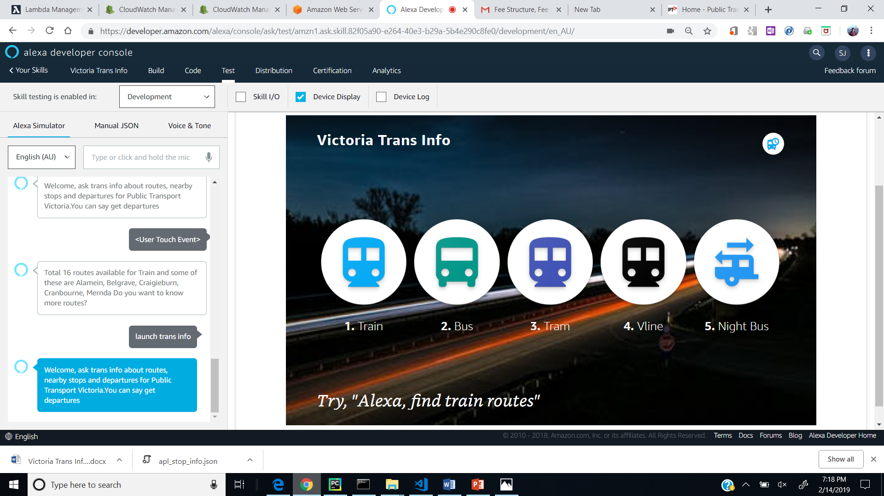

##### Step-2:

Click on any Icon of mode of transport to get the list of routes. e.g. train

##### 

##### Step -3:

Device shows the list of route for Trains. Select any route to get list of stops. E.g. ‘Alamein’

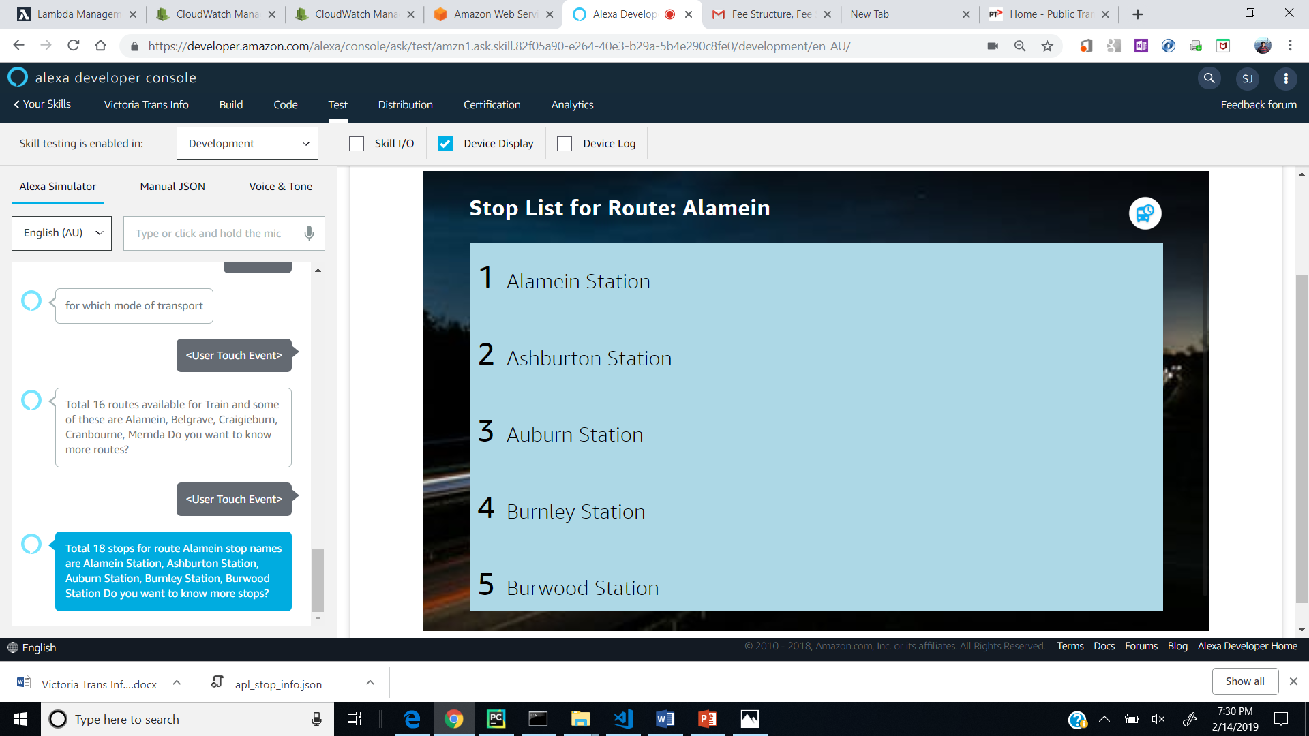

##### Step -4 :

Now on the screen which shows list of stops select any stops and tap, next 5 departures will be displayed. e.g. by selecting Auburn Station , departures are displayed as shown below

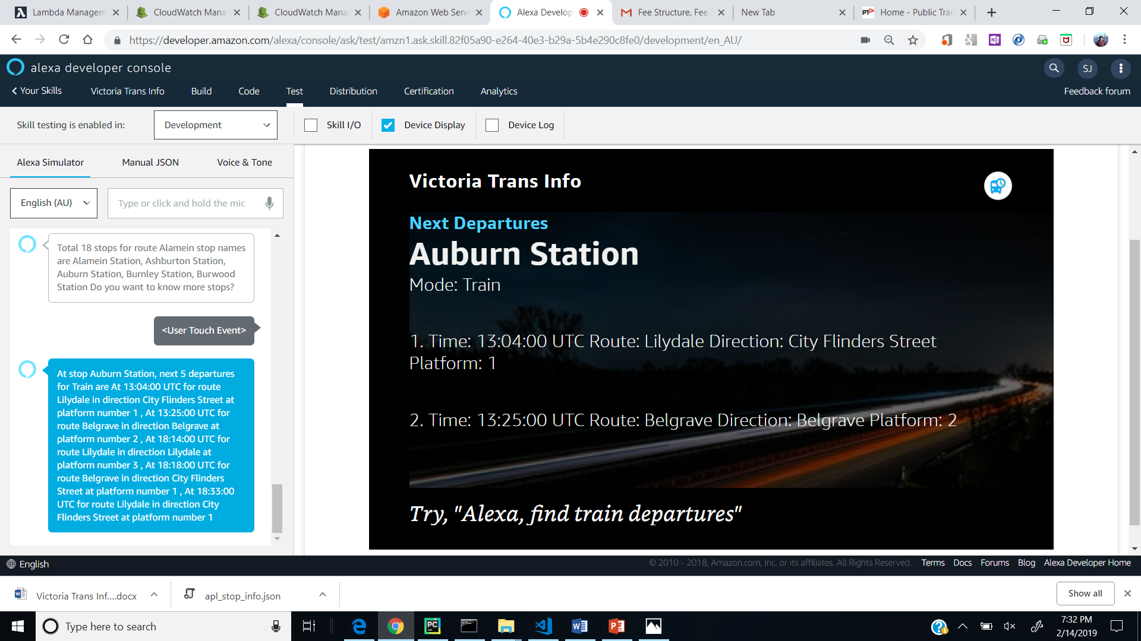

##### Test for Nearby Stops:

After launching the skill ask for nearby stops by saying “search nearby stops” following screen shall be displayed:

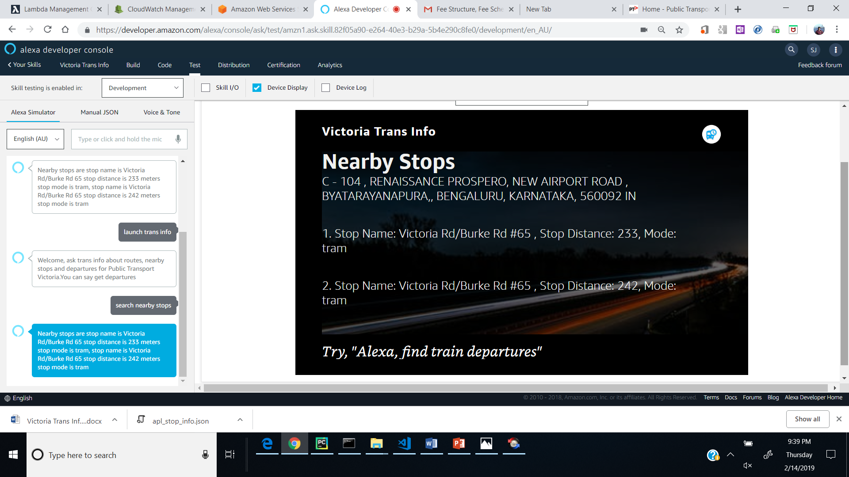

##### Test for Stop Info:

After launching skill ask for information about by saying “get stop info” e.g.

